A PROJECT PLANNING REPORT

ON

**Alerting Vehicle from Passage of Road Camels on the Road to Reduce Roads Accidents**

By

Murshid Abdullah Al-Alawi, 19f18977

Guided by

Shaik Mazhar Hussain

A Project Planning report submitted in partial fulfillment of the requirements for the award of

Bachelors in Electronics & Communication Engineering

cid:image003.jpg@01CF54C6.1873BE10

**MIDDLE EAST COLLEGE**

Knowledge Oasis Muscat, Muscat, Oman

January, 2023

A PROJECT PLANNING REPORT

ON

**Alerting Vehicle from Passage of Road Camels on the Road to Reduce Roads Accidents**

By

Murshid Abdullah Al-Alawi, 19f18977

January, 2023

**DECLARATION**

I, **“*Murshid Abdullah Al-Alawi*”,** hereby declare that the work presented herein is genuine and has not been copied in part or in whole from any other source except where duly acknowledged. As such, all use of previously published work (from books, journals, magazines, internet, etc.) has been acknowledged within the main report to an item in the references or bibliography lists.

Copyright Acknowledgement

I acknowledge that the copyright of this project and report belongs to MEC.

Student Name Student ID Signature

Murshid Abdullah Al-Alawi 19f18977

# APPROVAL FORM

The project planning report entitled **Alerting Vehicle from Passage of Road Camels on the Road to Reduce Roads Accidents** submitted by **Murshid Abdullah Al-Alawi, 19f18977** is approved in partial fulfillment of the requirements for degree of Bachelors of Engineering in Electronics & Communication Engineering

_________________________

Supervisor

Full name:

Department:

Date:

_______________________

Examiner

Full name:

Department:

Date:

# ACKNOWLEDGEMENT

The writer desires to express his/her sincerest appreciation and thanks to everyone who helps him for his encouragement and advice through the course of this study and for his help in the preparation and writing of this report.

Thanks go to the Head and faculty members of the Department of Electronics and Communication for supplying the source of information and resources for this work.

Thanks are also due to Supervisor for reading and checking the format of this report and guiding throughout the semester.

# ABSTRACT

Our proposed system, Camel/Vehicle Accident-Avoidance system is a system that uses newest technologies such as IoT to automatically detect and notify the drivers about the existence of a camel on the road. The problem solved by our system is to reduce the number of yearly deaths caused by car/camel accidents. The first and most important aim is to save as much lives as possible and to provide safer trips to read drivers.

The SDLC Water flow methodology will be followed over this research to be able to implement a camel detection system using Arduino Microcontroller and to build an application that receives the notifications send by the system and allocate the camels locations. Our Came/Vehicle Accident-Avoidance system will have a huge positive impact on society by helping Royal Oman Police reduce the percentage of cars/camels accidents on the highways, main roads, and side roads.

# TABLE OF CONTENTS

ACKNOWLEDGEMENT i

ABSTRACT ii

TABLE OF CONTENTS iii

LIST OF FIGURES v

LIST OF TABLES vi

LIST OF ABBREVIATIONS vii

1 INTRODUCTION 1

1.1 Background of the Project 1-2

1.2 Proposed Approach 2

1.2.1 Project Aim 2

1.2.2 Project Objectives 3

1.3 Applications 3

1.4 Project limitations 3

1.5 Overview of the Project Report 4

2 METHODOLOGY 5

2.1 Applied Methodology 6

2.2 Conclusion 7

3 LITERATURE REVIEW/THEORY 8

3.2 Technologies Based On Roadways 10

3.3 Animal-based technologies: 10-11

3.4 Vehicle-based technologies 11

3.5 Technologies based on communication 11-13

4 BUDGETING AND PROJECT MANAGEMENT 14

4.1 Project Budget 14

4.2 Project Schedule 14-15

4.3 Risk Management 16-17

5 DESIGN AND ANALYSIS 18

5.1 System Analysis 18

5.1.1 System Block diagram 18-20

5.1.2 System Flow chart 20-22

5.2 Requirements Analysis 22-26

5.2.1 Summarizing the key parameters from the Datasheet 26-27

5.3 System Design 27-28

5.4 System Test plan 29

5.4.1 Identifying test points 29

5.4.2 Developing Test Plans 30

6 CONCLUSIONS 31

REFERENCES 32-34

Appendix A 35-43

Appendix B 44-45

LIST OF FIGURES

# 

Figure 2.1 SDCL Methodology Main Stages (Alzayed, & Khalfan, A. 2022) ……………6

Figure 3.1 Camel Vehicle Collision (Al-Gadhi 2018) 8

Figure 3.1 Camel Causing Accidents on Roads Ashraf and Ansari said (2017)…………..9

Figure 5.1 Detailed Block Diagram 19

Figure 5.2 System Flow Chart……………………………………………………………21

Figure 5.3 Arduino Uno Detailed Components (FEC 2020)……………………………..22

Figure 5.4 Ublox NEO-6m (Datasheet 2022)…………………………………………….23

Figure 5.5 Lithlium Polymer Battery Ming-Chia Lai (2020)……………………………..24

Figure 5.6 SIM800L Illustration (Semiconductor Pinout Information 2020)……………25

Figure 5.7 SIM800L Pinout Details (Semiconductor Pinout Information 2020)…………25

Figure 5.8 Schematic Circuit Diagram 28

Figure 5.9 Illustrated Circuit Diagram 28

Figure 5.10 System Test Points 29

# LIST OF TABLES

Table 3.1 Summary of papers reviewed on Camel/Vehicle Accident-Avoidance 12

Table 4.1 Budget Required to Implement the System……………………………………15

Table 4.2 Gantt Chart for Project Scheduling 16

Table 4.3 PESTLE risk analysis 17

Table 5.1 Test Plan of the Testing Points…………………………………………………27

# LIST OF ABBREVIATIONS

| CVAA | Camel Vehicle Accident Avoidance |
| --- | --- |
| IoT | Internet of Things |
| GPS | Global Positioning System |
| GSM | Global System for Mobile Communications |
| PS | Power Supply |
| UI | User Interface |
| UX | User Experience |
| SDLC | System Development Life Cycle |
| GPRS | General Packet Radio Service |

# INTRODUCTION

Many people lost their lives due to camel accidents that took place on roads in Sultanate of Oman, the size of the camel is one of the factors that affect the injury type, most of the vehicle/camels’ collisions causes serious damages in head, chest, spinal cord (Al Shimemeri, & Arabi, Y. 2019).

People Lives are precious, working on this project was driven from our inner responsibility in saving peoples life. The main problem is that camel moving freely without any control can cause multiple accidents on the road and may target anyone who lives in the sultanate of Oman.

Our main objective is to build a full integrated Camel/Vehicle Accident Avoidance (CVAA) system and application that can solve this issue by making use of the technology that is now between our hands such as IoT, the system will consist of two main parts, the camel neck bracelet and the application that will be installed on the driver’s smart mobile device.

The project has some limitations, such are Power supply, data coverage, people’s awareness towards the problem, and more. However, we worked hard on collecting data and trying to overcome most of the limitations in the sake of building a successful CVAA system.

## Background of the Project

According to the traffic system report published by the National Center for Statistics and Information in Oman, numbers revealed that camel's/vehicles collision accidents raised by 17% during 2021 (Heyman T., 2021).

Many times, camels are left to move free by their owners, which provide a big chance that the camel approach the roads or highways that are taken by vehicles drivers, the driver get surprised by the camel on the road and doesn’t have the chance to stop or avoid the clash. In order to help stopping these types of tragedies, our study propose a smart system that uses IoT and other technological concepts in order to detect the camel once it approaches the road and automatically uses the build in GSM module to send an alert notification to the driver indicating the camel’s location on Google Map.

During his research Lao et, al. (2020) found that cars on higher speed have a higher chance to collide with the animal, also he stated that the location of the camel if the road was in urban city or Rural city also effect the availability of animal on the road

Meena, & Loganathan, A. (2020) suggested in her research suggested animal detection system for various types of animals using the technology called d Sparse Network of Winnows by taking image of the animal detected and identify animals on highways, however this study lacks the transfer of information to the driver, and it is highly complicated to implement, on the other hand errors can occur easily.

Injuries are directly related to the size of the camel, the speed of the vehicle, passengers’ use or avoidance of seat belts, and the protective reflex movements taken to avoid collision. Cervical and dorsal spinal injuries, especially fractured discs, head, and chest injuries, are the most commonly reported injuries.

Bartonicka, et,al (2018) published a study about the factors that may cause an accident between a car and an animal and one of his findings stated that the sun height compared to the horizon have a big effect of increasing accidents if the animal was on the road.

The project is important as it will help people's lives during their road trips between the sultanate cities, it will also help people feel more safe during the trip and reveals the tension and worries related to the sudden appearance of a camel in front of them on the road.

## Proposed Approach

### Project Aim

The aim of our proposed camel/vehicle collision avoidance system is to achieve a safe road during travels both on highways and on side roads by reducing the car/camels’ accidents that causes a lot of life loss. To achieve our aim, the study proposes an implementing a system that can detect the driver about the existence of a camel on a road once it crosses defined boundaries.

### Project Objectives

The below objectives are the main steps that we will be following for achieving the aim of the proposed system:

* To Build a camel tracker bracelet that is placed on the camel neck and is powered by rechargeable lithium polymer battery.
* To build a mobile application that receive the alerts send by the camel’s tracking bracelet and allocate the camel on the road.
* To build-in GPS tracking system to detect the camel’s location once it is on/near the road and a Build-in GSM Module that uses 2g/3g to send alert to the driver’s mobile application.

## Applications

Our project has a huge positive impact on society by reducing the yearly percentage of deaths caused by camel/vehicle collisions. Our proposed system will serve a huge number of local citizens in Oman and will be used to provide a safer and camel free road.

The proposed project can be also used in other countries for detecting different types of animals that can jump into the roads with slight adjustments.

## Project limitations

During our studies about various sides of the proposed Camel/Vehicle accident-avoidance system, we find some limitations as stated below

* Limited resourced on using GPS to specify the boarders of the roads
* Limited knowledge in programming Arduino Microcontroller and the need of using external learning tools to complete the task.
* The old mind set of camel’s owners who are living inside the desert and the effort needed to convince them using the system.

## Overview of the Project Report

The rest of the report consists of 5 chapters which are: methodology, literature review, budgeting and project management, design & analysis and finally a conclusion and future recommendation.

In chapter two, the methodology used to implement this system will be discussed. In chapter two, literature review studies the similar existing projects background and the previously proposed systems related to this project.

The third chapter is budgeting and project management, this chapter explains the project development which includes information on the timeline such as Gantt chat and information about the budget such as a detailed requirements budget table.

The fourth chapter will address the design and analysis of the camel/vehicle collision system in which the initial details for implementing the prototype are stated, it also lists the result we reached and all the limitations and hard issues we faced while implementing the prototype. While the last chapter will state the conclusion and our future recommendation on the proposed system.

# METHODOLOGY

The applied research methodology is the approach that is used to conduct applied research. It involves a set of steps that guide the research process, from defining the research question and objectives, to collecting and analyzing data, to reporting and disseminating the findings. Here is a comparison of five common methodologies that are often used in applied projects:

1. Agile: Agile is a flexible, iterative approach to project management that emphasizes collaboration, flexibility, and rapid prototyping. It is well-suited to projects that involve a high degree of uncertainty or complexity.
2. Lean: Lean is a methodology that focuses on maximizing value and minimizing waste in the project process. It is often used in manufacturing and service industries.
3. Six Sigma: Six Sigma is a data-driven approach to problem-solving that aims to eliminate defects and improve process efficiency. It is often used in manufacturing and service industries.
4. Scrum: Scrum is a framework for Agile software development that emphasizes regular, iterative progress and continuous improvement. It is often used in software development projects.
5. Water-Flow SDLC: SDLC (System Development Life Cycle) is a framework that outlines the steps involved in the development of a new information system. It is a systematic approach to designing, building, testing, and deploying a new system, and it is often used by organizations to ensure that the system meets the needs of the users and the business. The SDLC includes a detailed planning phase, an analysis phase, a design phase, an implementation phase, a testing phase, a deployment phase, and a maintenance phase.

After comparing the above existing methodologies, we can ensure that following Water-Flow system development life cycle for completing the different phases and parts of this project as it aligns perfectly with our project outcomes. On the other hand, we will use Critical Path Method to prioritize work, where all the activities will be listed such as Plan, Analyze, Design, Implement, and Maintain (Alzayed, & Khalfan, A. 2022), and work will be prioritized based on the on the tasks that are falling on critical path.

## Applied Methodology

Water-flow SDLC consists of 6 main stages that can be followed until the full project is implemented as shown in Fig 2.1. The first stage is to analyze the project idea and other sides of the project, it is also called the planning phase, in this step of the process we will conduct research about the idea and gather information using the literature review. Our findings at this stage will allow us to move to the second stage which is the system design. In the system design stage we will be designing and marking what the main features that we need to have in our system, we also finalize our UI and UX.

The third step in the process is to implement the system using all the data and system design you already finalized at earlier stages. Once implementation is finished the system needs to be tested to make sure all the functions are working as wished, and to ensure an error/bug free system. After testing the required development could be done either to overcome faults or to add features that produce a better final system. Finally, the system will be maintained for preventing failures. A picture containing graphical user interface
Figure 2.1 SDCL Methodology Main Stages (Alzayed, & Khalfan, A. 2022)

## Summary

Following Water-flow SDCL methodology will allow us to reduce the time needed in implementing the project and work in a very organized manner in order to reach the final system that we are planning to build in the sake of reducing the number of car/camels accident in the Sultanate of Oman.

# LITERATURE REVIEW/THEORY

**3.1 Introduction**

Every year, hundreds of accidents involving camel-drawn vehicles are reported, costing the Saudi economy billions of Saudi Dirhams and taking the lives of countless people. According to Gadhi's analytical synopsis of traffic accident statistics, well over 600 camel-vehicle collisions take place annually Al-Gadhi (2018). The issue is the huge number of camps for owners of internal camels are frequently located near major roads. They gather here until they are hungry, thirsty, or in season to breed. Sharing the road with herds, especially at night, is extremely risky for drivers

Most desert camels are not kept under control, so they roam free and occasionally crossroads without looking both ways, which can be dangerous Fig.3.1., especially at night. Because there is nowhere to turn and therefore no means to minimize a collision, camel animals on the carriageway are a driver's worst nightmare. At the Saudi Armed Forces Hospital, researchers studied 140 patients with low-neck spinal cord injuries. Forty-nine 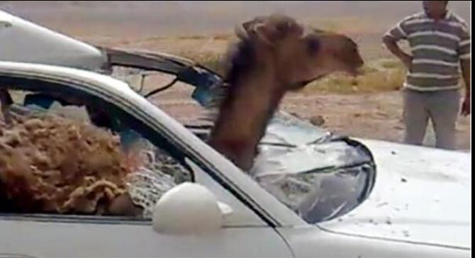

Figure 3.2 Camel Vehicle Collision (Al-Gadhi 2018)

percent of the customers were involved in camel-related car accidents. Reporters Ashraf and Ansari said (2017).

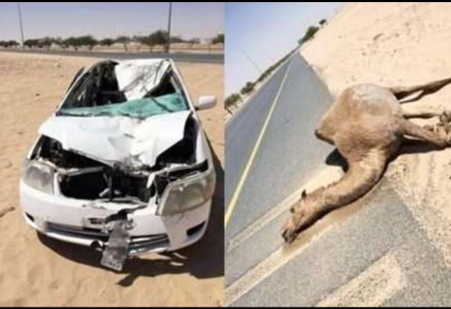

Figure 3.3 Camel Causing Accidents on Roads Ashraf and Ansari said (2017).

Camels are involved in 97% of all recorded AVCs, approximately ninety percent of these occurrences happen after dark. As well as causing millions of dollars to be lost, many lives and limbs to be lost, rare and valuable species to be wiped out, and extensive property damage, these events now have much serious negative consequences, economy, or society as a whole Fig3.3. To better understand how to prevent accidents at camel passes on rural Saudi highways, Al-Gadhi (2018).

There have been global efforts to reduce fatal AVCs using a wide range of technologies. We classify the many methods that have been implemented to reduce AVC incidence as follows. methods that rely on roadways, animals, and motorized transport and Communication.

## 3.2 TECHNOLOGIES BASED ON ROADWAYS

Fencing has been installed to prevent animals from wandering into traffic Clevenger et al., (2021). Fencing off sections of a road is a well-known conventional strategy for reducing AVC. Ward claims that a big-game fence that is just two meters in height can significantly cut down on deer-vehicle collisions. These underpasses and overpasses are particularly useful for wildlife since they have been integrated with traditional wildlife crossing infrastructure.…

Technologies for detecting vehicles, as opposed to those for detecting animals, work on a somewhat different concept. Sounds like trains and planes can be heard, but no animals have been seen. Large animals are warned of the presence of a car or train through a variety of noises and 366 visual signals. Visible signals from stations along the corridor's right-of-way, as stated in the Asian Journal of Computational Sciences (Huijser & McGrown, 2017).

## 3.3 Animal-based technologies:

For animal safety, different collars were utilized to activate an emergency plan, such as flashing lights, in the event of an animal collision. Collars like these can either transmit radio waves or reflect light.

**Reflective collars:** To reduce AVC, the British Columbia Department of Energy conducted trials. Collars with reflective tape were placed on some animals so that they would be more visible to passing automobiles. (Tan and Huang, 2016).

**Radio collars:** There have been many projects utilizing radio collars since 1999. A system was placed on a stretch of Highway 101 at Sequim, Washington, that is about 4,827 meters long, on the Olympic Peninsula. In 1999, radio collars were placed on roughly 10% of the herd's elk. Radio collaring of lead cows was attempted, but not always successful. The receivers at the roadsides are constantly tuning in to find the signals from the numerous radio collars. When the microphone people are fewer than 400 meters from the road, the receivers that pick up the signal activate the flashing lights connected to that receiver. A significant majority different receivers are available. In most cases, only one receiving can pick the signals at a time, but if the guy is wearing the electromagnetic collar is located anywhere in the middle of the distance between two receivers, then the signal may be picked up by both. Only two receivers are linked to the single flashing beacon (Dodd, 2017)

## 3.4 Vehicle-based technologies:

Vehicles equipped with animal detection systems can avoid collisions with large animals that wander into the road. Signs are activated to alert drivers that a large animal has been spotted on or near the roadway.

Technology installed in vehicles (often infrared detectors) can warn drivers when a large animal is at a certain distance from the car. Drivers require adequate stopping space to avoid hitting animals. The technique would not require any additional hardware by the side of the road and would be able to detect and identify large mammals anywhere they occur. It is unclear, however, if these on-board devices are still being manufactured.

## 3.5 Technologies based on communication

Various research in the subject of communication have utilized various instruments for data exchange from one individual, such as from user to user or persons to animal. Autonomous Community Information System, as proposed by Ragab et al. (2019), provides a decentralized information distribution infrastructure to meet the rising demand for timely content delivery. The goal of developing ACIS was to facilitate better two-way dialogue between the product's final consumers. Specifically, the system accomplishes this goal by employing an application-level multicast strategy that can dynamically grow to support huge groups of users. The ACIS system also features a scalable community creation and maintenance architecture that simplifies the management of an internet discussion network. Ragab et al. (2019),

Table 3.1 Summary of papers reviewed on Camel/Vehicle Accident-Avoidance

| Title, Author, Year | Concepts, approach, methods and analysis, | Inconsistencies, gaps, contradictions, differences | Improvements |
| --- | --- | --- | --- |
| Paul Fergus, 2022 Intelligent Systems Using Sensors and/or Machine Learning to Mitigate Wildlife–Vehicle Collisions | Uses Machine Lerning, data sets to minimize faults in detecting animals using artificial intelligence based methods | Most of the ADSs in use today are insufficient for midsized animals. The system is unable to detect smaller animals which require immediate focus in developing techniques that reduce WVCs across all life forms. | Set an algorithm for a system that detects animals using real time data |
| Zahara Batool, 2021 Road safety issues in Pakistan: a case study of Lahore | Qualitative analysis of the state's highway safety challenges was conducted. | Did not specify solutions to prevent animal vehicle collision accidents on the road | We recommend creating additional fresh, enhanced, and effective solutions. |
| De Molenaar, J.G. and R.J.H.G Henkens, 2028, Effectiveness of Wildelive Mirrors. | Fencing Installed have been studied to prevent animals from wandering into traffic | No use of technology in solving the problem | Smart fencing or other tools using technology can be used |
| Huijser, M.P. and P.T. McGowen, 2003. Overview of animal detection and animal warning systems in North America and Europe. | Large animals are warned of the presence of a car or train through a variety of noises and 366 visual signals. Visible signals from stations along the corrido’s right of way. | There is no warning about the animal to the driver, and its only warning the animal. | Warning signals for both the animals and the drivers is required. |

**3.6 Summary**

Comparing different technologies used in previous researches we found that there was lack in using Internet of things to solve the problem of camel/vehicle collision accidents. Most of the studies relied on non-technological solution such as fencing and reflective signs, while others relied on radars to detect the animals including camels, these solutions are costlier and doesn’t ensure a safe driving environment. Hence we will be implementing our system by making use of IoT.

The literature review done to study the various systems and techniques that are currently available and the newest technologies and studies that focus on home safety and security systems, the literature review will help in gathering useful data, which will allow one to get a better understanding of the problem and provide us with a wider scope of solutions. The next stage is to design the system front and back ends. The literature review stage will serve as the foundation for the design, development, and testing phases.

# BUDGETING AND PROJECT MANAGEMENT

# Budgeting and project management are important considerations in applied projects, as they help to ensure that the project is completed on time, within budget, and to the desired level of quality.

# Project management involves coordinating and controlling the various activities that need to be completed as part of the project. This involves creating a project plan, setting milestones and deadlines, and tracking progress against these targets. It may also involve managing risks, communicating with stakeholders, and making decisions about how to allocate resources.

## Project Budget

## Budgeting: In applied projects, it is important to have a clear understanding of the financial resources that are available for the project, and to develop a budget that reflects the costs of all the activities that need to be completed. This may include costs such as labor, materials, equipment, and travel, as well as any contingency funds that are needed to cover unexpected expenses.

Table 4.1 Includes all the components that will be used to implement the system and the price for each component based on a market research conducted, the table include the equipment such as the Arduino Uno Microcontroller, and the SIM800L, it also includes the cost of the tools such as the fixing tools, and finally it included the cost of the software that will be used for illustrating the circuit diagrams.

Table 4.1 Budget Required to Implement the System

| Item | Budget in OMR |
| --- | --- |
| Microcontroller ( Arduino UNO) | 24 |
| GSM Module (SIM800L) | 15.4 |
| Power supply (Lithium Polymer Battery) | 7 |
| GPS Module | 5 |
| Wires | 4.4 |
| Fixing Tools | 20 |
| Connection board | 8.0 |
| Software’s packages installation | 30.0 |
| Total | 113.8 |

## Project Schedule

A project schedule is a timeline that outlines the key tasks and milestones that need to be completed in order to complete a project successfully. It is an important tool for project management, as it helps to coordinate the efforts of the project team and ensure that the project stays on track and is completed on time.

## 4.2.1 Gantt Chart

The below Table 4.2 is the Grantt Chart that illustrates how the main tasks required to accomplish the project will be scheduled to be implemented over the semester until the 15th week.

Table 4.2 Gantt Chart for Project Scheduling

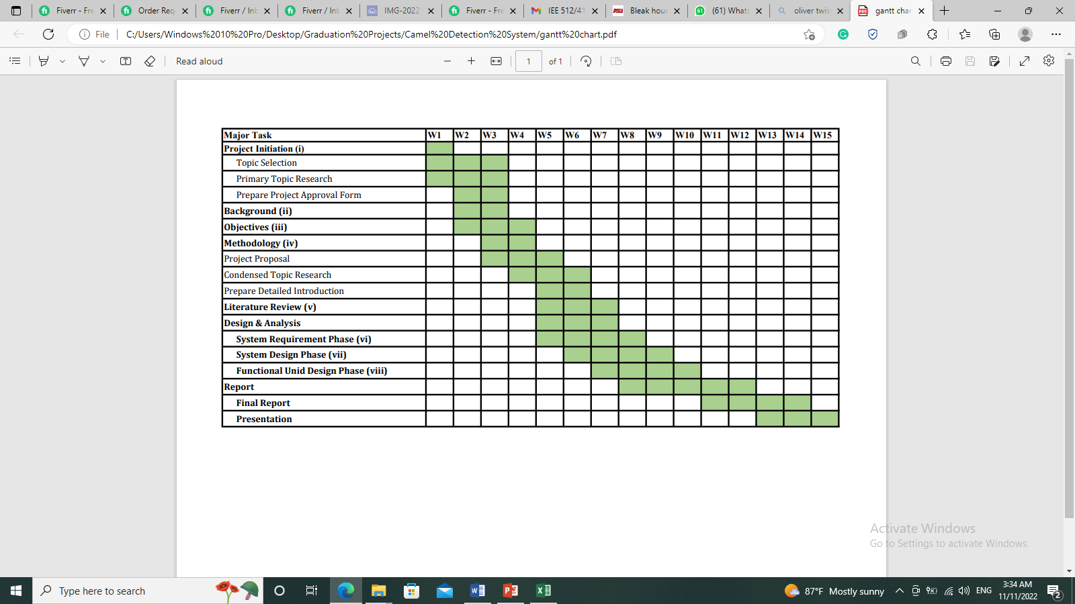

## Risk Management

Risk management is an important aspect of designing and implementing a camel vehicle accident avoidance system. The goal of risk management is to identify, assess, and prioritize potential risks that may occur during the operation of the camel vehicle and to implement measures to mitigate or eliminate those risks. Baxter. (2010)

There are several steps involved in risk management for a camel vehicle accident avoidance system:

* Identify potential risks: This involves identifying all the potential hazards and risks that may occur during the operation of the camel vehicle. This may include risks related to the system itself, such as mechanical failure or malfunctions, as well as external risks.
* Assess the likelihood and impact of each risk: Once potential risks have been identified, it is important to assess the likelihood of each risk occurring and the potential impact it may have. This will help prioritize the risks and determine which ones need to be addressed first.
* Develop risk mitigation strategies: Based on the assessment of the likelihood and impact of each risk, strategies can be developed to mitigate or eliminate the risk. These strategies may include implementing safety measures, such as installing sensors or warning systems, or implementing operational procedures to minimize the risk of accidents.
* Implement risk mitigation measures: Once the risk mitigation strategies have been developed, it is important to implement the necessary measures to reduce or eliminate the identified risks. This may involve installing new equipment or modifying existing systems, as well as training operators on the proper use of the camel vehicle and the risk mitigation measures in place.
* Monitor and review risk management processes: It is important to regularly review and monitor the risk management processes to ensure that they are effective in mitigating the identified risks. This may involve collecting data on accidents or near-accidents and analyzing it to identify trends and areas for improvement. Baxter. (2010)

Table 4.3 Identify Pestle risk analysis, which indicates risk associated with the project from various aspects such as political, economic, social, technological, legal and environmental

Table 4.3 PESTLE risk analysis

| Political risks | The implementation of the alerting vehicle system may require government approval or funding, which could be subject to political factors such as changes in government policies or budgets. |
| --- | --- |
| Economic risks | The cost of implementing and maintaining the alerting vehicle system may be a barrier for some users. |
| Social risks | The system may face backlash or criticism from members of the community who object to its use or who believe it is unnecessary. |
| Technological risks | The system may be vulnerable to technical failures or glitches that could disrupt its operation. |
| Legal Risks | The system may be subject to legal regulations or requirements related to data privacy, data security, or intellectual property. |
| Environmental risks | The system may be affected by environmental factors such as extreme weather conditions or natural disasters. |

# DESIGN AND ANALYSIS

## System Analysis

Our System will consist of two main parts, the first part is a designed necklace that will be placed on the camel’s neck to allocate its location and send real time data once the camel reaches the road or is near the road.

While the second part of the system is the application that will be installed on the driver’s mobile device, the main role of the application is to receive the alerts that are send through the camel’s neck bracelet and to activate an alerting buzzer while showing the exact camels location on Google map.

In this chapter we will include the system analysis from various aspects, such as the detailed block diagram and the process flow chart.

### System Block diagram

The Block diagram of our proposed system is composed of two blocks since the system will be sending data through the camel neck bracelet and receiving data through the drivers’ mobile application.

Block 1 is the smart camels necklace that will placed on the camel’s neck and it consists of all the hardware components. The block 1 system will be powered by the rechargeable lithium polymer batteries and will collect real time location data using the GPS (Global Positioning System) module. The data of the camels real time location will be received by the Arduino Uno which it will be processed and filtered, once the data indicates that the camel is on the road or near the road (with a range of 5m), the Arduino will use the GSM module (SIM800L) to automatically send 2g/2g notification over the internet with the help of the General Packet Radio Service (GPRS) which is built in the Sim800L.

The send data will be received in our second block which is the user’s mobile application. The application will be designed and installed on the drivers mobile to receive all the alerts send by the camel necklace system (block1). Therefore, the application have 3 major roles: to receive the alerting notification, to activate a sound alert to notify the driver about the danger, and to show the driver the exact location of the camel using Google Map.

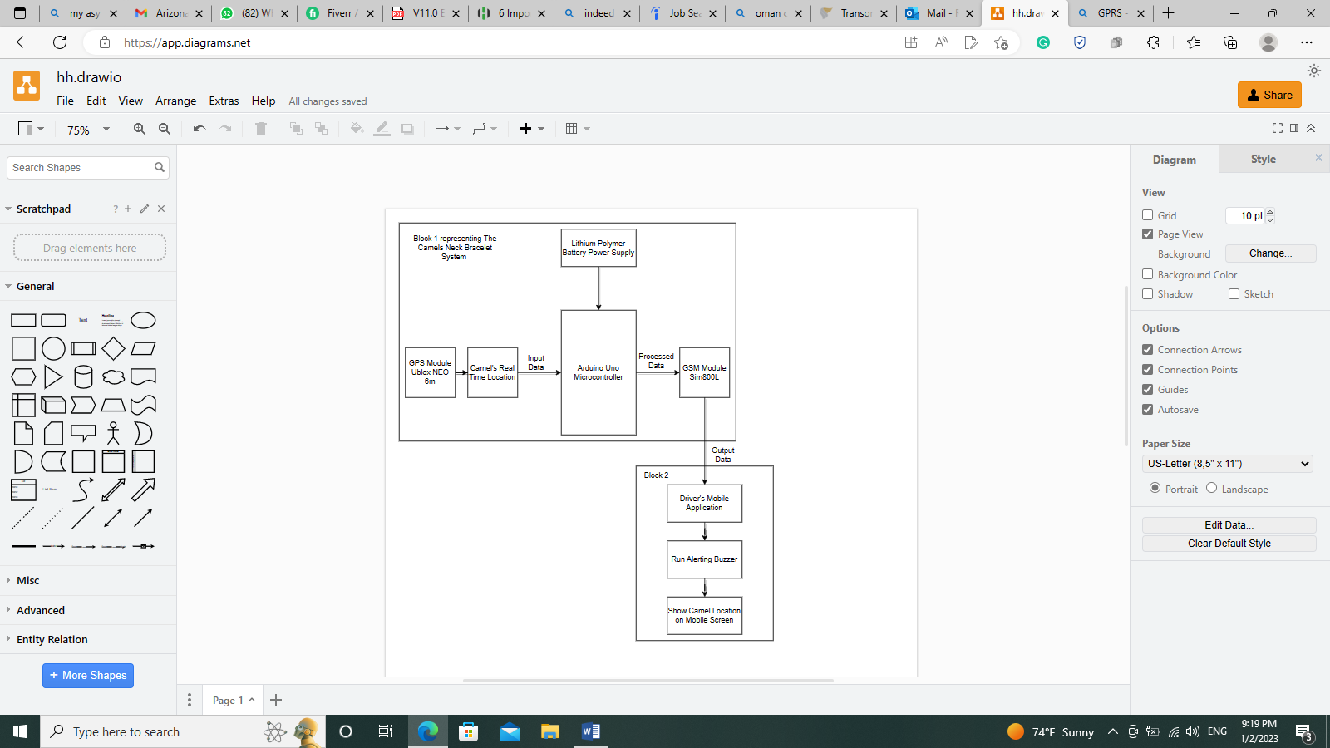

We will be using only 2g/3g signals as this is the only supported techniques in the SIM800L build in GPRS. The GPRS (General Packet Radio Service) core network is a system that enables 2G, 3G, and WCDMA mobile networks to transmit Internet Protocol (IP) packets to external networks such as the Internet. It is integrated into the GSM (Global System for Mobile Communications) network switching subsystem. The GPRS system offers a range of services, including SMS messaging and broadcasting, "always on" internet access, MMS (Multimedia Messaging Service), PoC (Push-to-talk over cellular), instant messaging and presence, and access to internet applications through WAP (Wireless Application Protocol). Using SMS over GPRS can provide a transmission speed of around 30 SMS messages per minute, which is faster than the typical speed of 6 to 10 SMS messages per minute using SMS over GSM.

On the other hand, for detecting and deciding that the camel is crossing the road the following steps will be used:

1- We Will Set up a virtual perimeter around the road using GPS coordinates. We can do this by defining a set of GPS coordinates that form a polygon around the area where we want to detect animal crossings.

2- In our Arduino program, we will check the GPS coordinates of the animal against the virtual perimeter. If the animal's coordinates fall within the perimeter, it means the animal is crossing the road.

3- When an animal crossing is detected, the Arduino program can trigger an action, such as sending a notification.

### System Flow chart

The system flow chart summarizes the main tasks that will be carried by the full system and specify the logical order in which the tasks will follow. The system will include an input data that will be provided by the GPS module, a condition which may be true or false, a processing unit that is the Arduino UNO which will be programmed to process the data received from the GPS module, and lastly we will be having the outputs represented by audio alert which notify the driver about the presence of the camel on road, and a visual output which shows the drivers the camels exact location on the road using Google Map.

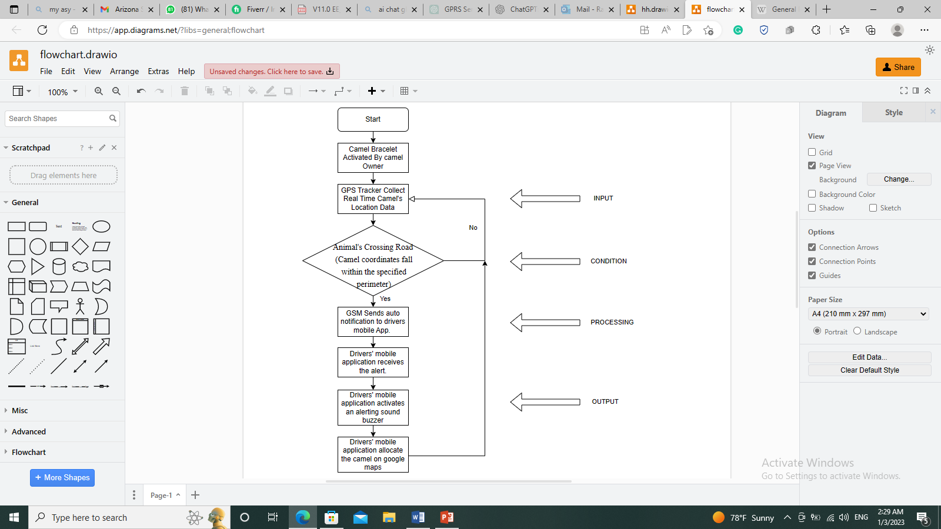

Figure 5.2 System Flow Chart

**Applied Scenario for the above Condition:**

1- If animal_latitude >= perimeter_min_latitude && animal latitude <= perimeter_max_latitude && animal_longitude >= perimeter_min_longitude && animal_longitude <= perimeter_max_longitude)

// animal is crossing the road

// trigger action (e.g. activate LED, send notification)

}

2- else {

// animal is not crossing the road

// do nothing}

## Requirements Analysis

The proposed system will require both hardware and software development phase.

The hardware main components include the following:

* **Arduino Uno Microcontroller:** The Arduino Uno is a microcontroller board based on the ATmega328 Microcontroller. It has 14 digital input/output pins, 6 analog input pins, a 16 MHz crystal oscillator, a USB connection, a power jack, an ICSP header, and a reset button.

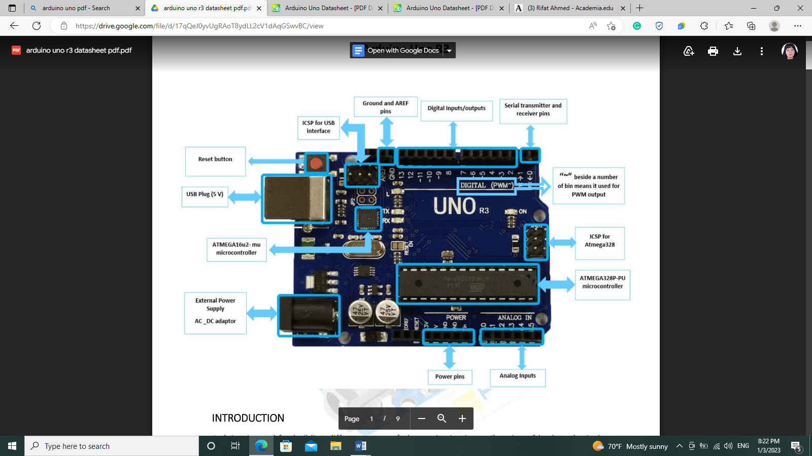

Figure 5.3 Arduino Uno Detailed Components (FEC 2020)

* **GPS Module (Ublox NEO-6m):** The Ublox NEO-6m GPS module is a compact, high-performance module that uses the Ublox NEO-6m GPS chip. It is designed for use in a variety of applications, including drones, robotics, and vehicle tracking. The module is capable of tracking up to 22 satellites and provides location accuracy of up to 2.5 meters. It also has a built-in low-power consumptions mode, making it suitable for use in battery-powered applications. The Ublox NEO-6m GPS module has a number of communication interfaces, including UART, I2C, and SPI, making it easy to connect to a variety of microcontrollers and processors.

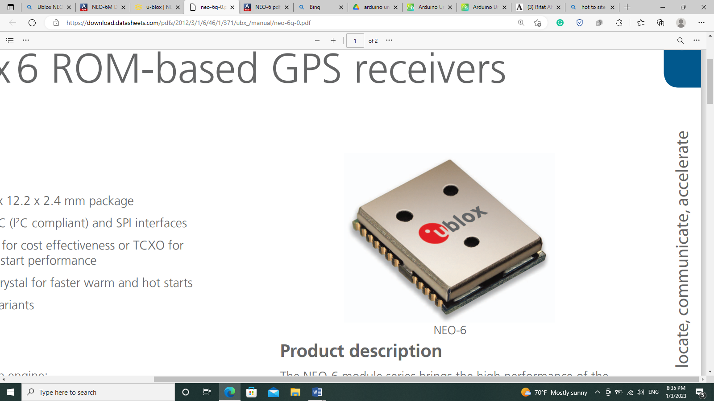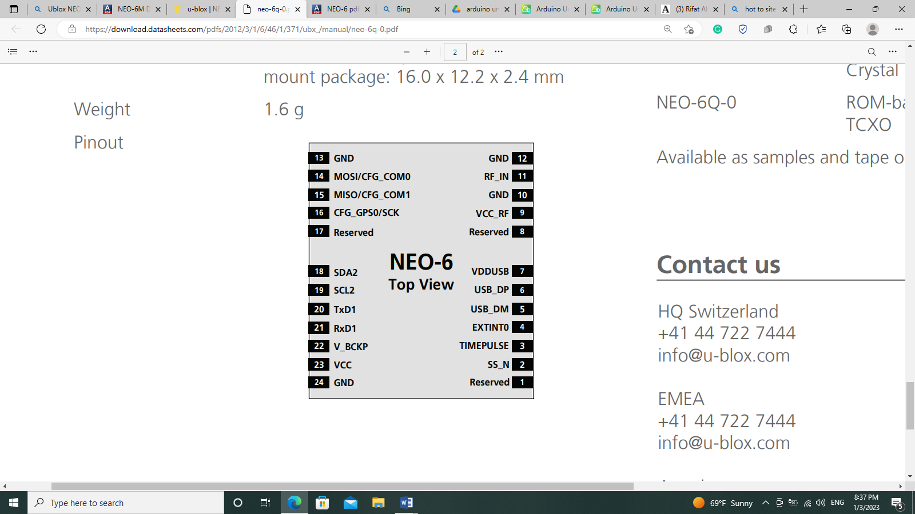

Figure 5.4 Ublox NEO-6m (Datasheet 2022)

* **Power Supply (Lithium Polymer Battery):** Lithium polymer batteries (LiPo batteries) are a type of rechargeable battery that uses lithium-ion technology. They are made of thin, lightweight polymer sheets that contain a lithium-ion battery cell. LiPo batteries are known for their high energy density, which means they can store a lot of energy in a small amount of space. They are also relatively lightweight and have a good power-to-weight ratio, making them popular for use in portable electronic devices and small, lightweight systems.

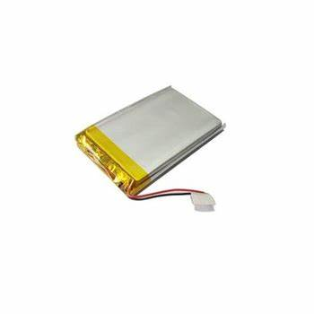

Figure 5.5 Lithlium Polymer Battery Ming-Chia Lai (2020)

* **GSM/GPRS Module (SIM800L):** The SIM800L is a compact, low-power, and low-cost GSM/GPRS module that is designed for use in a variety of applications, including mobile phones, portable devices, and machine-to-machine (M2M) communication. It is based on the SIM800L GSM/GPRS chip, which is a low-power consumption quad-band GSM/GPRS module that supports GSM/GPRS 850/900/1800/1900 MHz. The SIM800L module has a number of communication interfaces, making it easy to connect to a variety of microcontrollers and processors.

The SIM800L module is commonly used in applications that require wireless communication, such as GPS tracking, security systems, and remote monitoring. It is also popular in DIY electronics projects and is often used in conjunction with an Arduino or other microcontroller.



Figure 5.6 SIM800L Illustration (Semiconductor Pinout Information 2020)

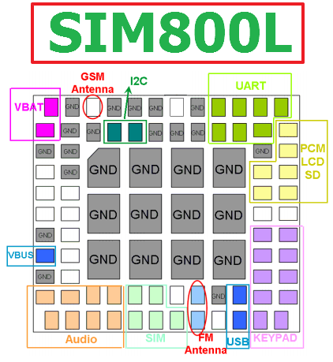

Figure 5.7 SIM800L Pinout Details (Semiconductor Pinout Information 2020)

Software Requirements:

The system will also require the help of some software for both planning and programming phases as follows:

* The Arduino Uno is programmed using the Arduino Integrated Development Environment (IDE), which is a cross-platform application that runs on Windows, Mac OS, and Linux. The Arduino Uno can be used to control a wide variety of electronic devices
* Gg. drawio to present the flowcharts and the circuit diagrams
* Visual basic to program the user device mobile application using programming language (Java-Script)

### Components key Parameters

The below key parameters are specific for each and every main hardware component used and it is extracted from the datasheet of each component.

**Arduino Uno:**

* Microcontroller: ATmega328P
* Operating Voltage: 5V
* Input Voltage (recommended): 7-12V
* Input Voltage (limits): 6-20V
* Digital I/O Pins: 14 (of which 6 provide PWM output)
* Analog Input Pins: 6
* DC Current per I/O Pin: 40 mA
* DC Current for 3.3V Pin: 50 mA
* Flash Memory: 32 KB (of which 0.5 KB is used by bootloader)
* SRAM: 2 KB
* EEPROM: 1 KB
* Clock Speed: 16 MHz

**Ublox NEO-6m**

* Frequency: L1 (1575.42 MHz)
* Sensitivity: Tracking: -162 dBm, Cold starts: -148 dBm
* Time-To-First-Fix (TTFF): Cold starts: 26 s, Aided starts: 2 s
* Accuracy: 2.5 m CEP
* Protocol: NMEA, UBX
* Baud rate: 4800, 9600 (default), 19200, 38400, 57600, 115200
* Operating temperature range: -40°C to +85°C
* Supply voltage: 3.3V
* Dimensions: 22.5 x 25 x 2.4 mm
* Weight: 2.4 g

**Lithium Polymer Battery**

* Voltage: The standard average single cell voltage for lithium polymer cells is 3.6 volts. The minimum voltage at which the cell should be turned off is 3.0 volts, and the maximum charging voltage is 4.2 volts.

**SIM800L**

* Frequency bands: GSM 850/900/1800/1900 MHz
* Protocols: GSM, GPRS, SMS, USSD, TCP/IP, FTP, HTTP, PPP
* Baud rate: Up to 115200 bps
* Operating voltage: 3.4-4.4V
* Operating temperature: -30°C to +80°C
* Dimensions: 24 x 24 x 3 mm
* Weight: 2.5 g

## System Design

The below Figures illustrate the system circuit diagram design and connection including all of the main components, the Microcontroller, the GSM module, the GPS module, the buck converter and the battery. 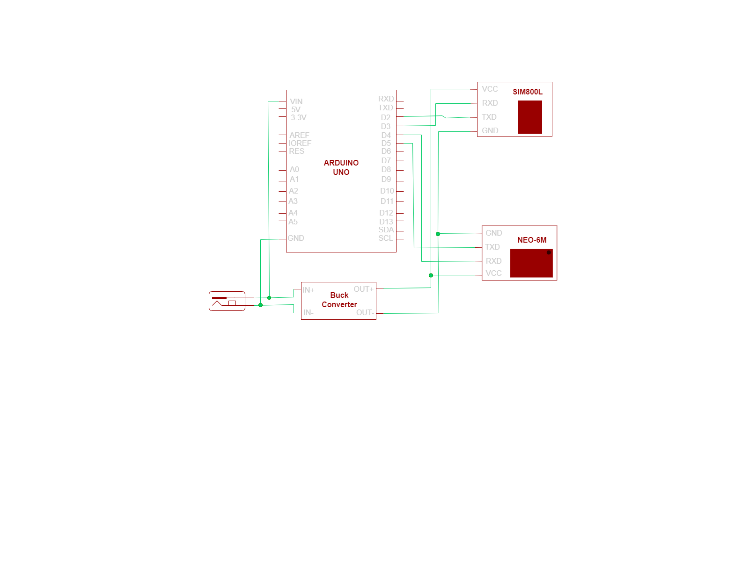

Figure 5.3 Schematic Circuit Diagram

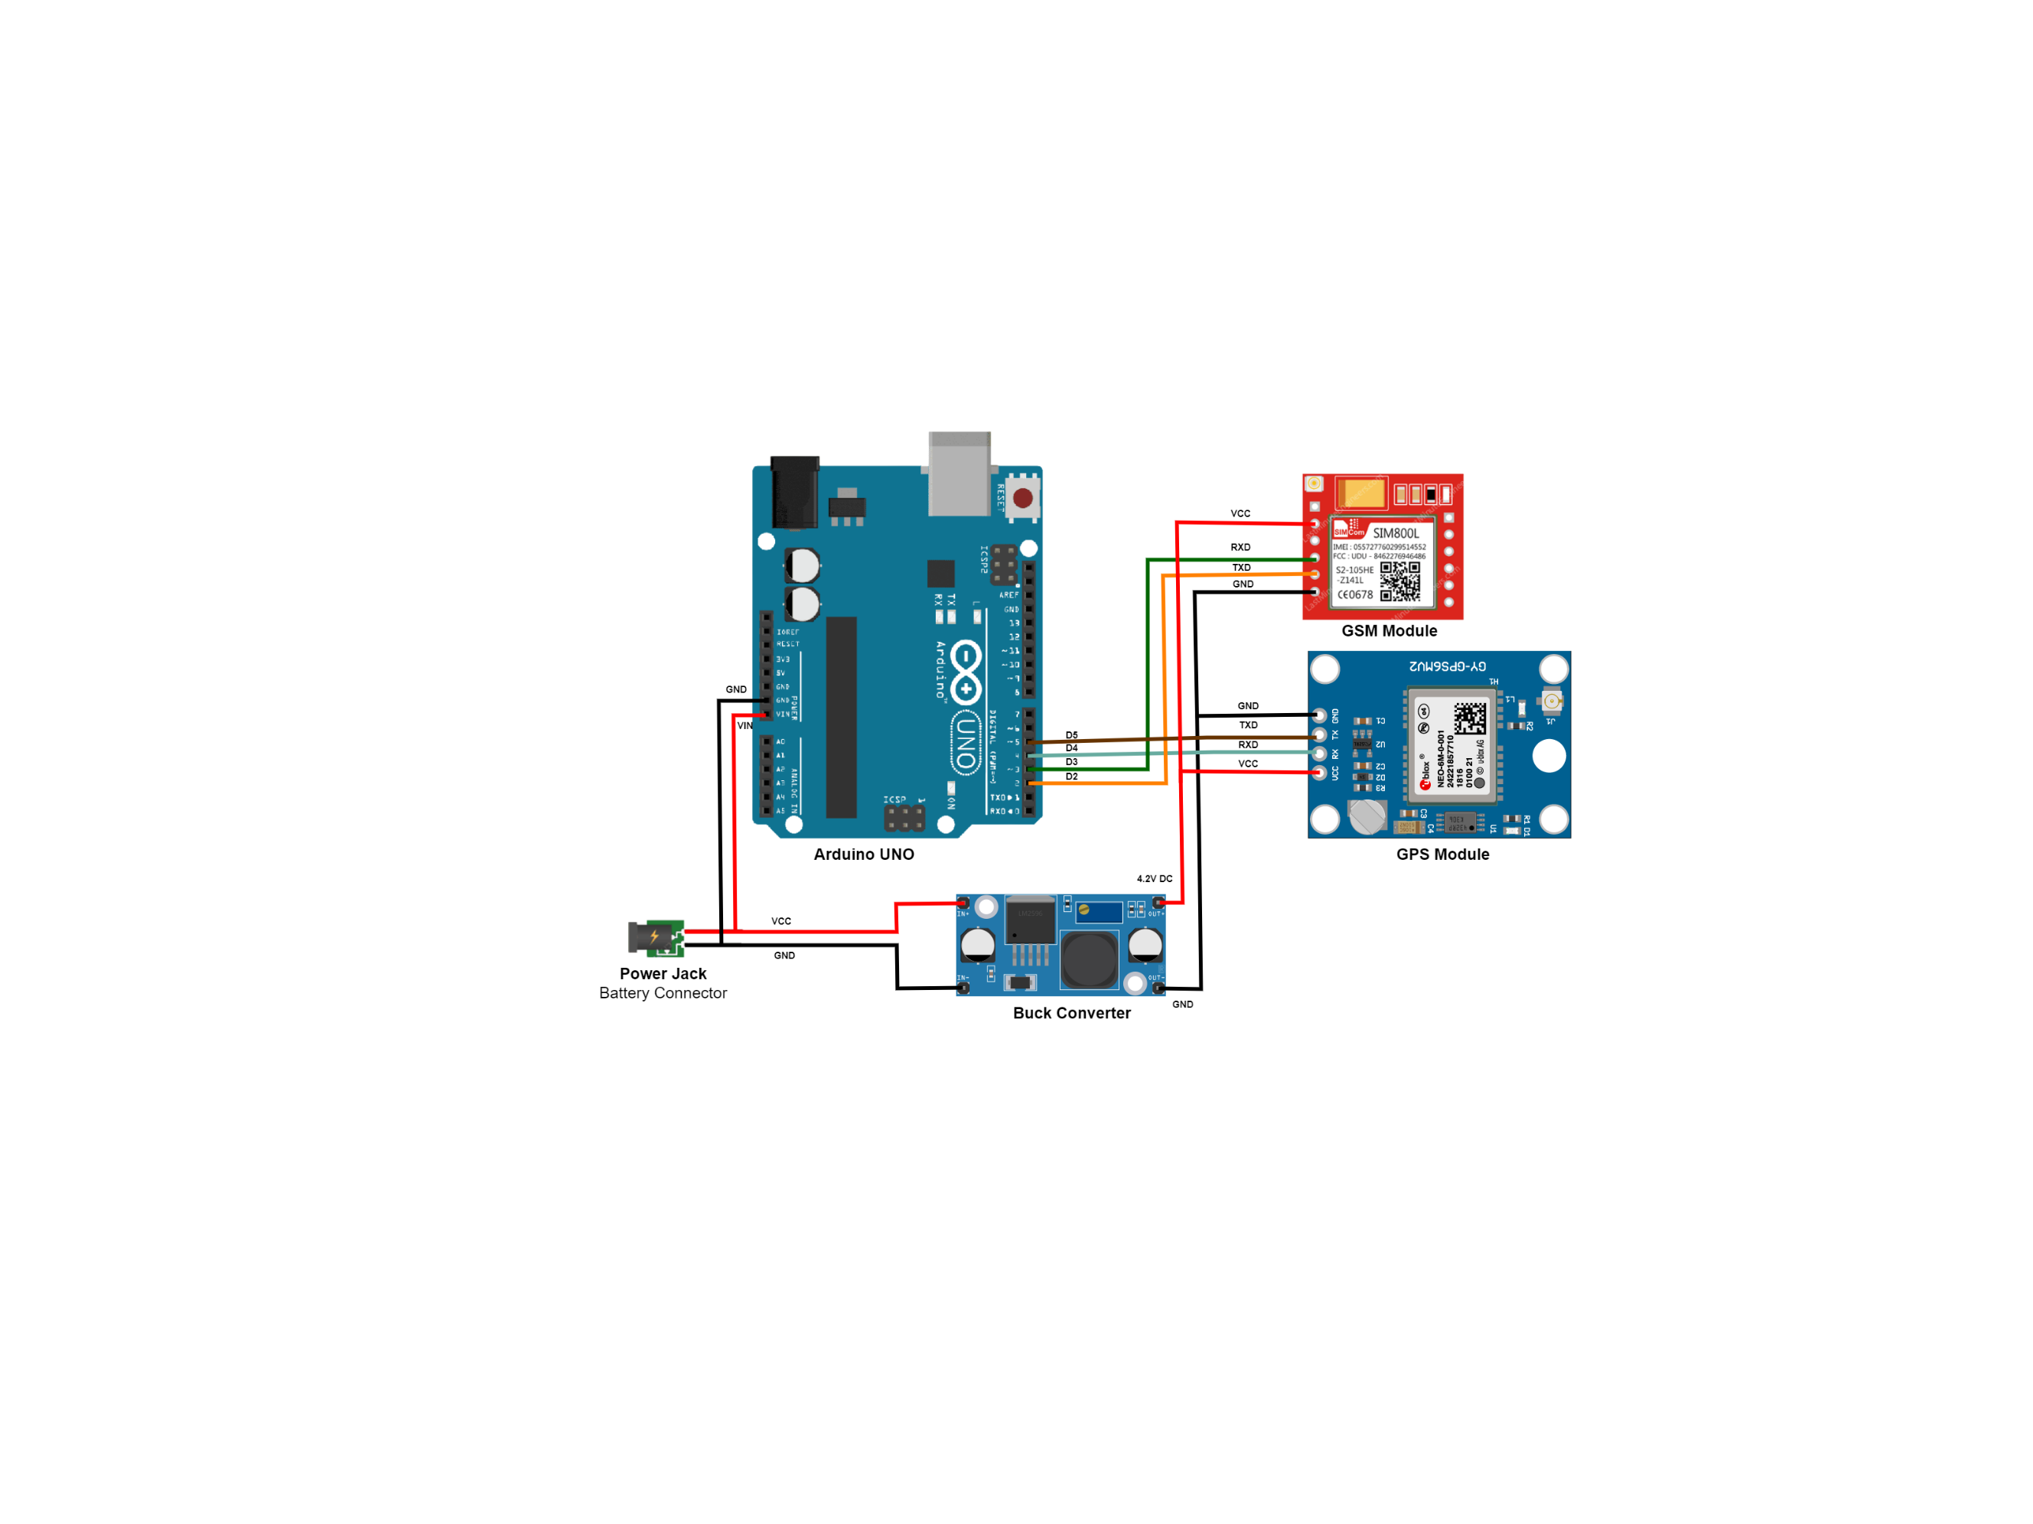

Figure 5.4 Illustrated Circuit Diagram

## System Test plan

The system requires various testing and validation of components full working condition in the desired manned, therefore a well-established testing plan is configured to indicate the test points and to propose the suitable way for testing.

### Identifying test points

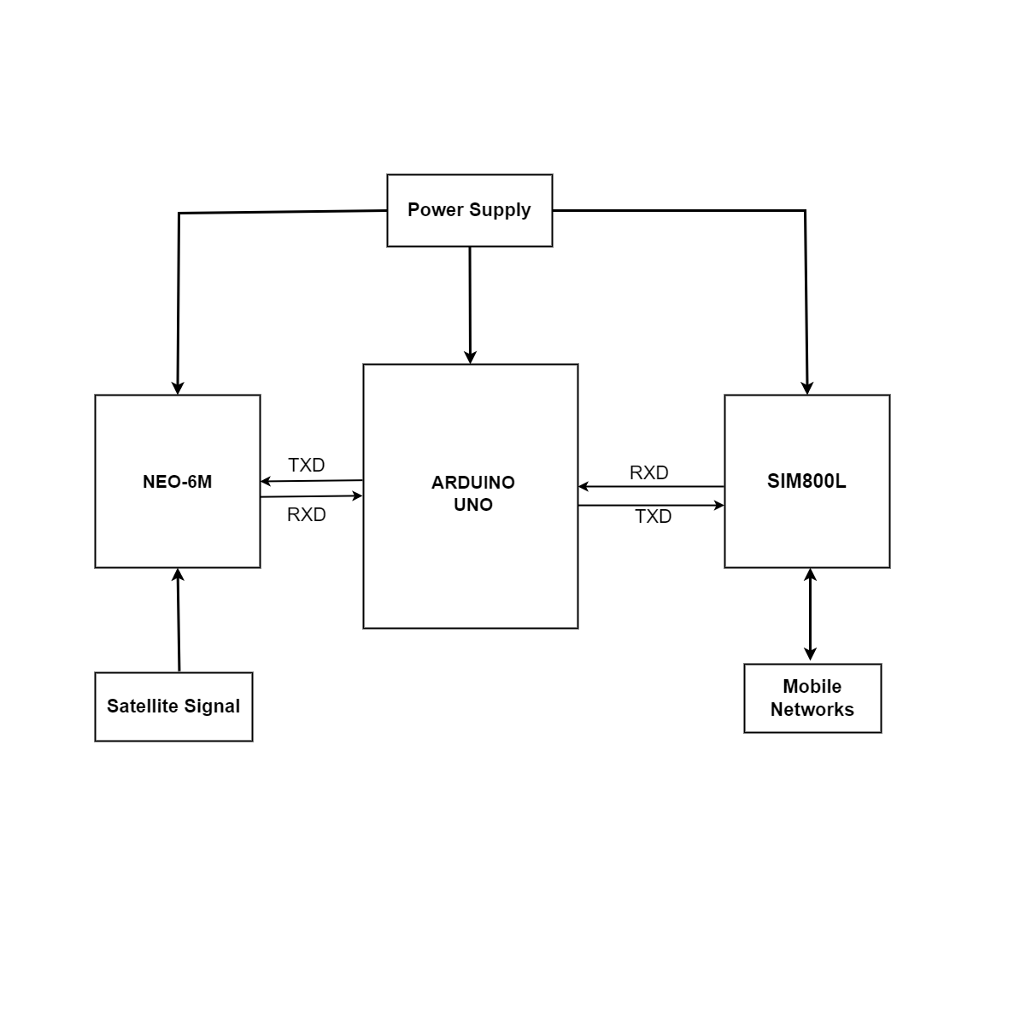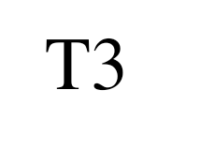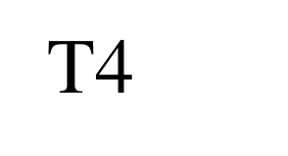

Figure 5.5 System Test Points

### Developing Test Plans

The test points showed in Fig.2 will be tested as per the bellow table.

Table 5.1 Test Plan of the Testing Points

| **T1** | The Battery will be tested using a volt meter to check if the supplied voltage is around 3.6 Volt |
| --- | --- |
| **T2** | Real time locations will be verified to ensure stability |
| **T3** | Verify the accuracy of the received location by the Microcontroller |
| **T4** | Measure the verify that the location of the camel is within a range of less than 5m to the road |
| **T5** | Test and verify the success automatic sending/receiving of the data on the mobile app |

# CONCLUSIONS

The Camel/Vehicle Accident-Avoidance system is a unique and innovative solution to a significant problem facing society today: the high number of car/camel accidents on the roads, which can result in loss of life and serious injuries. By using the latest technologies, such as IoT and GPS tracking, the system is able to detect the presence of camels on the road and notify drivers in real-time, allowing them to take appropriate action to avoid a collision.

The proposed system involves the development of a camel tracking bracelet, which is placed on the camel's neck and equipped with a GPS tracking system and a GSM module. The bracelet is powered by a rechargeable lithium polymer battery and is able to detect the camel's location and send alerts to the driver's mobile application when the camel is on or near the road. The mobile application, which is also developed as part of the system, receives the alerts and displays the camel's location on a map, allowing drivers to easily avoid any potential collisions.

To ensure the effectiveness and reliability of the Camel/Vehicle Accident-Avoidance system, the team will follow the SDLC Water flow methodology, which is a widely-used approach to software development that involves a series of well-defined steps to ensure a high-quality end product. This includes conducting thorough testing and analysis of the system's characteristics, such as latency, accuracy, and reliability, to ensure that it performs optimally and meets the needs of its users.

Overall, the proposed Camel/Vehicle Accident-Avoidance system has the potential to make a significant positive impact on society by helping to reduce the number of car/camel accidents on the roads and providing a safer environment for all travelers.

# REFERENCES

Heyman, Taylor. (2021) Car accidents involving stray camels in Oman up 17%. *In Gulf*, [Car accidents involving stray camels in Oman up 17% in 2021 (thenationalnews.com)](https://www.thenationalnews.com/gulf-news/oman/2022/10/17/car-accidents-involving-stray-camels-in-oman-up-17-in-2021/#:~:text=Oman%20has%20seen%20a%20significant%20increase%20in%20the,National%20Centre%20for%20Statistics%20and%20Information%20%28NCSI%29%20said.)

Al Shimemeri, & Arabi, Y. (2019). A review of large animal vehicle accidents with special focus on Arabian camels. Journal of Emergency Medicine, Trauma & Acute Care,

Alzayed, & Khalfan, A. (2022). Understanding Top Management Involvement in SDLC Phases. Journal of Software, 87–120.

Meena, & Loganathan, A. (2020). Intelligent animal detection system using sparse multi discriminative-neural network (SMD-NN) to mitigate animal-vehicle collision. Environmental Science and Pollution Research International, 27(31), 39619–39634.

Lao, Zhang, G., Wu, Y.-J., & Wang, Y. (2020). Modeling animal–vehicle collisions considering animal–vehicle interactions. Accident Analysis and Prevention, 43(6)

Bartonicka, Andrasik, R., Dula, M., Sedonik, J., & Bil, M. (2018). Identification of Local Factors Causing Clustering of Animal-Vehicle Collisions. The Journal of Wildlife Management, 82(5), 940–947.

Ansari, S. and A.K.S. Ashraf, (2017). Camel collision is a major cause of low cervical spinal cord injury. Spinal Cord, 36: 415-417.

Al-Ghamdi, A.S. and S.A. Al-Gadhi, (2018). Warning signs as countermeasures to camel-vehicle collisions in Saudi Arabia. Accid. Anal. Prev., 36: 749-760.

Clevenger, A.P., B. Chruszcz and K. Gunson, (2021). Highway mitigation fencing reduces wildlife-vehicle collisions. Wildlife Soc. Bull., 29: 646-653.

Huijser, M.P. and P.T. McGowen, (2017). Overview of animal detection and animal warning systems in North America and Europe. Proceedings of the 2003 International Conference on Ecology and Transportation, (ET'03), Raleigh, NC, USA. pp.: 368-382.

Tan, H., Jihua Huang (2016) DGPS-Based Vehicle-to-Vehicle Cooperative Collision Warning: Engineering Feasibility Viewpoints. Computer Science, IEEE Transactions on Intelligent Transportation Systems

Dodd, N.L., J.W. Gagnon, S. Boe, A. Manzo and R.E. Schweinsburg, (2017). Evaluations of measures to minimize wildlife-vehicle collisions and maintain permeability across highways: Arizona route 260. Final Report to Arizona Department of Transportation, ECS File No. JPA 01-152 JPA 04-024T.

Ragab K. Kaji, N. Horikoshi, Y. Kuriyama, H. Mori K. (2019). Autonomous Community Communication for Information Dissemination. IEEE Internet Computing 8(3):29 – 36

Irene N. Marcellin A. Patrice O. (2022) Intelligent Systems Using Sensors and/or Machine Learning to Mitigate Wildlife-Vehicle Collisions: A Review, Challenges, and New Perspectives. Sensors and Artificial Intelligence for Wildlife Conservation. 22(7), 2478;

Batool, Zahara (2021) Attitudes towards road safety and aberrant behaviour of drivers in Pakistan. PhD thesis, University of Leeds.

De Molenaar, J.G. and R.J.H.G Henkens, (2018), Effectiveness of Wildlife Mirrors: Een literatuurevaluatie. IBN Rapport 362. Institute Voor Bos-en Natuuronderzoek, Wageningen, The Netherlands.

Baxter. (2010). Risk management (1st edition). Financial Times/Prentice Hall.

Future Electronic Components FEC (2020), Arduino Uno Datasheet R3, <https://drive.google.com/file/d/17qQeJ0yvUgRAoT8ydLL2cV1dAqGSwvBC/view>

Datasheet (2022), NEO-6 ROM-based GPS receivers, <https://content.u-blox.com/sites/default/files/products/documents/NEO-6_ProductSummary_%28GPS.G6-HW-09003%29.pdf>

Ming-Chia Lai (2020) Lithium-Ion Polymer Battery for 12-Voltage Applications: Experiment, Modelling, and Validation, Energies, Mechanical Engineering, Electric-drive Vehicle Engineering, Wayne State University, Detroit, MI 48202, USA

Semiconductor Pinout Information (2020) SIM800L Datasheet – 4-band GSM/GPRS Module – SIMCom

**Appendix A**

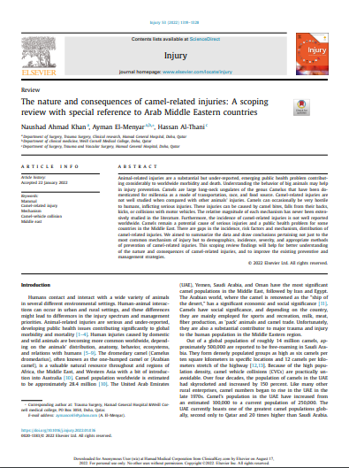

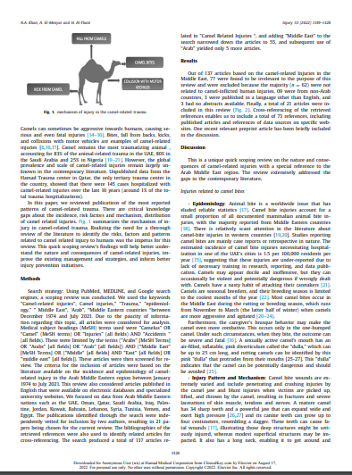

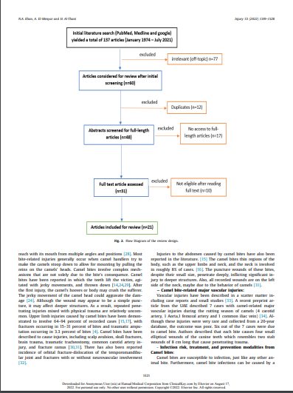

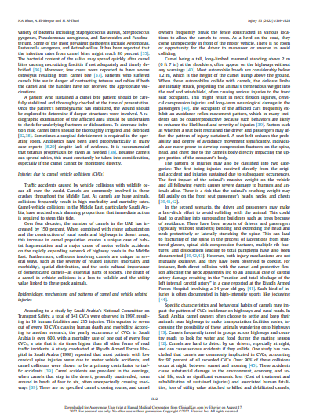

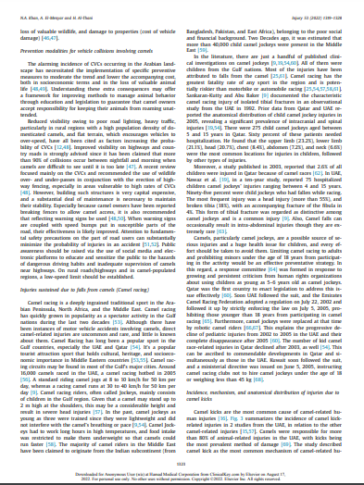

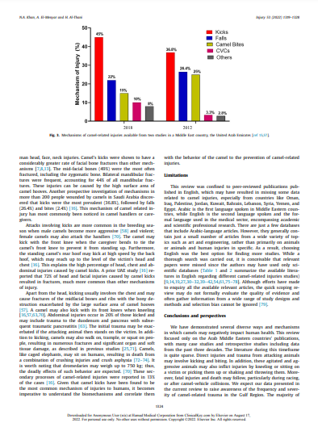

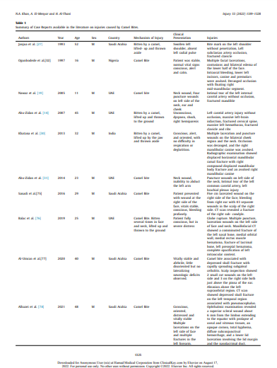

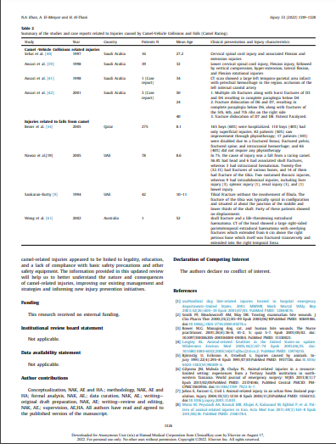

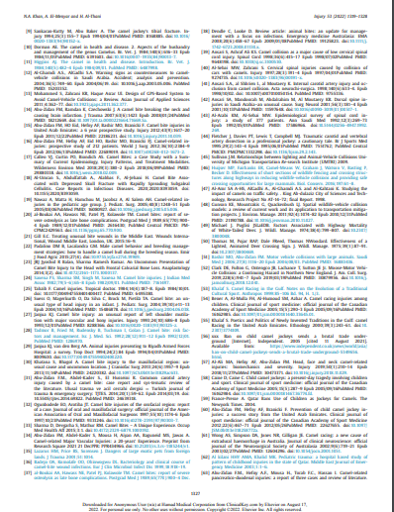

**Appendix B**



